

WaveWatch Project Phase A

**Supervisor: Dr. Reuven Cohen**

**Students: Eyal Cohen & Lior Zucker**

**liorzucker11@gmail.com**

**eyalaxl135@gmail.com**



***Table of Contents***

**1. Abstract 4**

**2. Introduction 5**

**3. Literature Review 7**

3.1 Background: 7

3.1.1 Wave Height 7

3.1.2 Swell Direction 7

3.1.3 Crowd Density 7

3.1.4 Swell Period 7

3.1.5 Wind Direction 8

3.1.6 wave duration 8

3.1.7 wave count per swell duration 8

3.2 Focus in our project 8

3.3 Related Work: 9

3.3.1 Classification of Surf Breaks: 9

3.3.2 Artificial intelligence for beach monitoring: 10

3.3.3 Analysis of waves using Beach Webcams: 11

3.3.4 Beach Monitoring: 12

3.3.5 Key Parameters for Optimal Surfing Wave Conditions 13

3.4 Existing Tools for Surf Condition Analysis 14

3.4.1 Beach Cameras: 14

3.4.2 Wave Forecasts: 14

3.4.3 Weather Forecasts: 14

3.5 computer vision background 15

3.5.1 Image Classification Using Machine Learning 15

3.5.2 CNN Image Classification 15

3.5.3 YOLO (You Only Look Once) 15

**4. Engineering Process 16**

4.1 Process 16

4.1.1 Methodology 16

4.1.1.1 Initial Planning: 16

4.1.1.2 Sprint Planning: 16

4.1.1.3 Development and Implementation: 17

4.1.1.4 Continuous Integration and Testing: 17

4.1.1.5 User Feedback and Refinement: 17

4.1.1.6 Deployment and Maintenance: 17

4.1.1.7 conclusion 17

4.1.2 Expected Achievements: 18

4.1.2.1 Product Infrastructure and Flow: 18

4.1.2.2 Criteria for Success: 18

4.1.2.3 Unique Features 19

4.1.2.1.1 YOLO-Based Real-Time Analysis 19

4.1.2.1.2 Multi-Parameter Evaluation 19

4.1.2.1.3 Customizable User Interface 19

4.1.2.1.4 Safety Insurance 19

4.1.2.1.5 Enhanced Data Visualization 19

4.2 Product 20

4.2.1 Product Architecture 20

4.2.2 use case : 21

4.2.3 user interface: 22

4.2.3.1 Dashboard 22

4.2.3.2 Video Playback 22

4.2.3.3 Detailed Reports 22

4.2.3.4 Parameter Analysis 22

4.2.4 paper prototype 23

4.2.5 Activity Diagram 26

4.2.6 Package Diagram 27

4.2.7 Requirements 28

4.2.7.1 Functional Requirements 28

4.2.7.2 Non-Functional Requirements 29

4.3 Testing Plan 30

**5. References: 34**

**6. Appendices 35**

# 1. Abstract

Surfing enthusiasts often face challenges in identifying the best conditions for catching waves, especially when considering skill level and current sea conditions. Human observation is limited in tracking and analysing real-time sea dynamics, which is crucial for safe and effective surfing.

WaveWatch is a machine learning based software application developed to enhance the analysis of sea conditions through beach video footage. Utilising the YOLO (You Only Look Once) architecture, the software processes videos to provide insights beyond human capabilities. A wide range of beach videos capturing various sea conditions and crowd densities will be collected and annotated with features like wave types and surfer counts to train the model.

The analysis will focus on critical parameters: swell period, wave duration , wave count per swell period and surfer count. The swell period will be calculated by measuring overall time of incoming waves, helping to predict patterns.wave duration will be assessed to determine the quality of a wave, while surfer counts will be used to estimate crowd density, which impacts overall surfing conditions, lastly wave count per swell duration will help extract the quality of a swell period.

Once trained, the model will process new video footage, extracting detailed insights into sea conditions. The results will be presented via visualisations. WaveWatch’s user-friendly design allows users to upload beach videos and receive comprehensive analyses, benefiting a wide range of users, including surfers, swimmers, lifeguards, and beach managers.

By integrating AI with real-time data, WaveWatch aims to improve beach safety and optimise surfing and water-based activities.

# 2. Introduction

The human eye has inherent limitations that prevent it from efficiently tracking waves and surfers, which significantly impacts the ability to analyse beach streams and wave conditions. This analysis is crucial for ensuring safe and effective surfing experiences. Currently, information on wave and weather conditions is available from various sources, including videos, beach streams, and forecasts provided by leading meteorology and ocean information companies in Israel and worldwide. Examples of such sources include goSurf, which displays the sources and companies it relies on for information, and Surfline, which employs a team of forecasters to provide precise daily updates.

To address these limitations, we propose developing a model that will analyse and present real-time sea conditions through a user-friendly web interface. This model will be based on several predetermined parameters informed by our experience as surfers and engineers, as well as input from a survey of the surfing community. The goals of this solution include performing rapid analysis using more parameters than the human eye can assess, generating relevant real-time status updates, and providing accurate and timely information about sea conditions.

The proposed solution will benefit a wide range of stakeholders. Beginner surfers will progress quickly by identifying suitable surfing times, while expert surfers will save time and effort with precise and timely information. Fishermen will be able to plan their trips more effectively and safely, and swimmers will be able to choose the safest times and locations for swimming. Lifeguards will benefit from improved beach safety monitoring and management, and municipalities will be able to make better decisions regarding beach maintenance and safety. Insurance companies will have better risk assessment capabilities and can manage claims related to water activities more efficiently. Beach exercisers will be able to plan their activities around the best conditions for a safer experience. Surf club owners will be able to schedule lessons and events at optimal times, and beach camera website owners will increase the value of their service by integrating real-time sea condition analysis.

The model will be based on the YOLO (You Only Look Once) architecture, which uses a single convolutional neural network (CNN) to spatially separate bounding boxes and associate probabilities with each detected image. This results in a probability of detection for the targeted objects. Key parameters for analysis include swell period, wave duration , wave count per swell period and surfer count. This comprehensive analysis will provide accurate real-time information for various stakeholders, ensuring optimal and safe use of sea conditions for different activities.

The project book will explore WaveWatch's AI-driven approach, using the YOLO architecture to analyze sea conditions from beach videos. It will cover key sections such as an introduction to current surf analysis methods, a literature review of background and existing tools, and the technical process behind the development of WaveWatch, focusing on parameters like wave duration and surfer counts. Each section will provide insights into the technology and methodologies applied throughout the project's development.

# **3. Literature Review**

## 3.1 Background:

This section will detail key parameters such as wave height, swell direction, crowd density, swell period, wind direction, tide, and water temperature. By understanding these factors, surfers can make informed decisions about the best times and locations for their activities. The aim is to present this information in a way that is both accessible and relevant, helping surfers of all skill levels optimize their time on the waves and enjoy a safer, more fulfilling experience.

### 3.1.1 Wave Height

Wave height is a crucial factor in determining good surfing conditions. Ideal wave heights can vary depending on the surfer’s skill level and preferences. Beginners can have an exhilarating experience even with waves of 70 cm, while experienced surfers look for waves of at least 1 or 2 meters.

### 3.1.2 Swell Direction

The direction of the swell, which is the wave system created in the open sea due to a storm, moving towards the shore, is essential for an ultimate surfing experience. In Israel, the optimal swell is a westerly swell. Sometimes, southwesterly or northwesterly swells may occur, and surfing should be adjusted to the precise angle at which the waves break on the shore. Additionally, the direction of the wave opening is important, with left-breaking waves preferred by goofy-footed surfers and right-breaking waves preferred by regular-footed surfers.[6]

### 3.1.3 Crowd Density

The number of surfers in the water impacts the surfing experience. More surfers often indicate good wave conditions, as people have already tested the spot. However, less crowded spots allow for more waves to be ridden and create a safer environment. Evaluating the crowd density can help in choosing the best time and place to surf.

### 3.1.4 Swell Period

Swell duration refers to the period during which a series of waves, or swells, persist in a given location. It specifically indicates the length of time over which multiple waves occur. Understanding swell duration is crucial as it helps gauge the consistency of wave activity. A longer swell duration often signifies more extended periods of favourable wave conditions, enhancing the chances of good surf.

### 3.1.5 Wind Direction

Offshore winds (blowing from the land to the sea) are generally preferred as they create smoother, more rideable waves. Onshore winds (blowing from the sea to the land) can make the waves choppy and less ideal for surfing.[6]

### 3.1.6 wave duration

Beach wave duration refers to the amount of time a wave lasts from the moment it begins to break until it fully dissipates. It helps determine the quality of the wave for activities like surfing, with longer durations often providing better surfing conditions.

### 3.1.7 wave count per swell duration

Wave count per swell duration is the number of waves that occur during a single swell period, which is the time that more waves occur. It helps assess the consistency and quality of waves within that swell, with more waves often indicating better conditions for surfing.

## 3.2 Focus in our project

In our project, we chose to focus on the number of surfers, the swell period, wave duration, amount of surfers and wave count for swell period. These parameters provide valuable insights into the quality of surfing conditions and help predict the best times and locations for surfing.

## 

## 3.3 Related Work:

### 3.3.1 Classification of Surf Breaks:

Until now, very little information, engineering or scientific criteria were available to quantify the difficulty of a surfing wave. Earlier studies suggested that the degree of difficulty or surfability) of a wave may be defined as a function of breaker height and peel angle . [1]

Author(s): James A. Hutt, Kerry P. Black and Shaw T. Mead

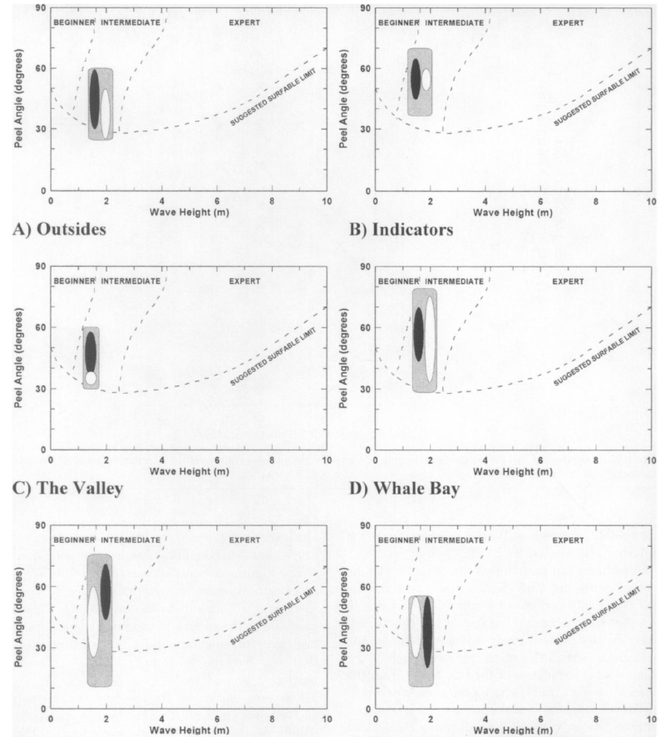

### 3.3.2 Artificial intelligence for beach monitoring:

This study proposes a novel approach to automating the counting process based on   
computer vision and artificial intelligence. Three HIKVISION PTZ surveillance cameras were installed on the roofs of strategic buildings of El Rodadero, Santa Marta, Colombia. This observation system provided more than 150,000 observations spanning more than a year (September 2022 – October 2023). An algorithm based on the YOLOv5 architecture was trained using a dataset containing over 50,000 labels of people at the beach or in water backgrounds. The model's user counts correlated strongly with human verification, achieving a coefficient of determination (R²) of 91%. These insights are critical for authorities to make informed decisions regarding beach management and for visitors to choose less crowded beaches, thereby preventing overcrowding.[2]

Authors: Richard Johnston-Gonzáleza, Eros Adarragaa, Oswaldo Cocaa, Marco Correaa.

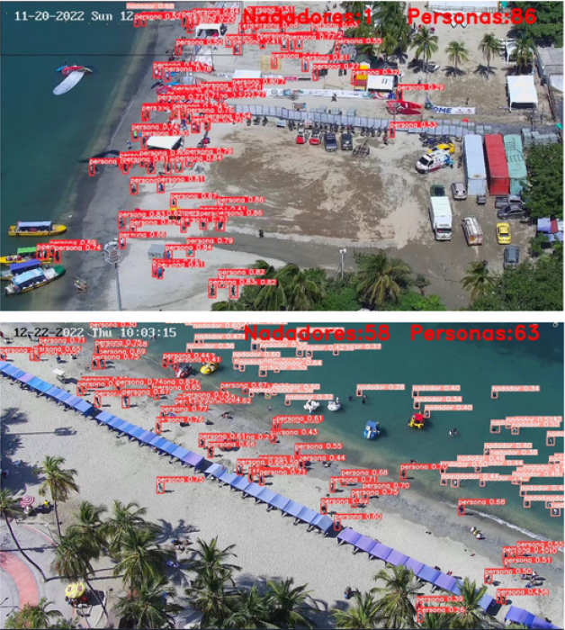

### 3.3.3 Analysis of waves using Beach Webcams:

Prior studies on this task have used videos from different sources for a variety of purposes, anging from the general study of wave breaking dynamics [5]–[7] or coastal monitoring [8] for analyzing surfing conditions [9], [10]. This task, like the task of people detection, was first approached using classical image processing methods [5], [9], and later with deep neural

networks [6]–[8], [10].[3] Authors: Harel Mendelman, Tomer Masssas, Yair Moshe

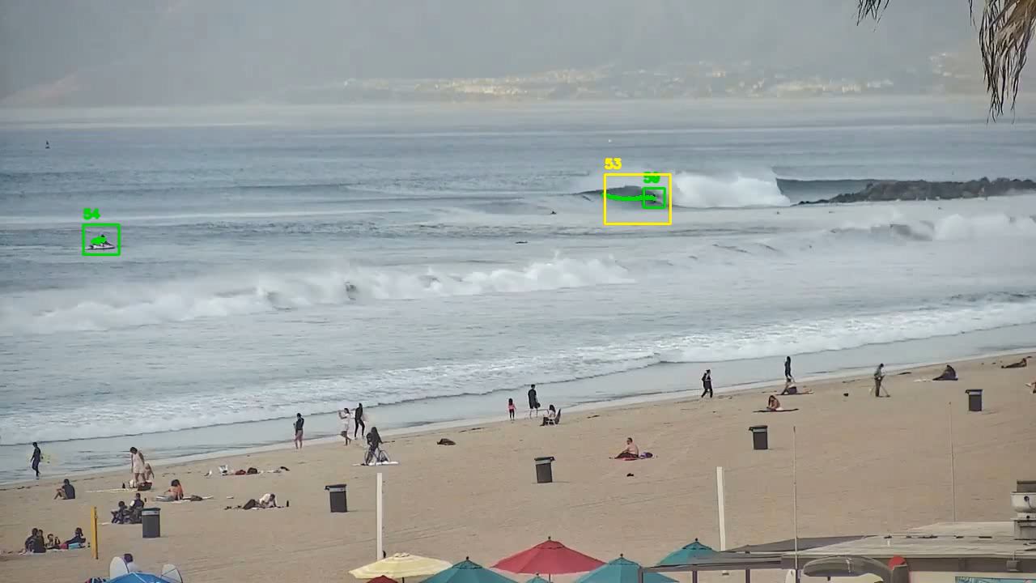

### 3.3.4 Beach Monitoring:

In this paper, an experimental study that uses IoT data and deep learning to predict the number of beach visitors at Castelldefels beach (Barcelona, Spain) was developed. Images of Castelldefels beach were captured by a video monitoring system. An image recognition software was used to estimate beach attendance.  
A deep learning algorithm (deep neural network) to predict beach attendance was developed. The experimental results prove the feasibility of Deep Neural Networks (DNNs) for beach attendance prediction. For each beach, a classification of occupancy was estimated, depending on the number of beach visitors. The proposed model outperforms other machine learning models (decision tree, k-nearest neighbors, and random forest) and can successfully classify seven beach occupancy levels with the Mean Absolute Error (MAE), accuracy, precision, recall and F1-score of 0.03, 92.7%, 92.9%, 92.7%, and 92.7%, respectively.[4]

Author: Mari Carmen Domingo

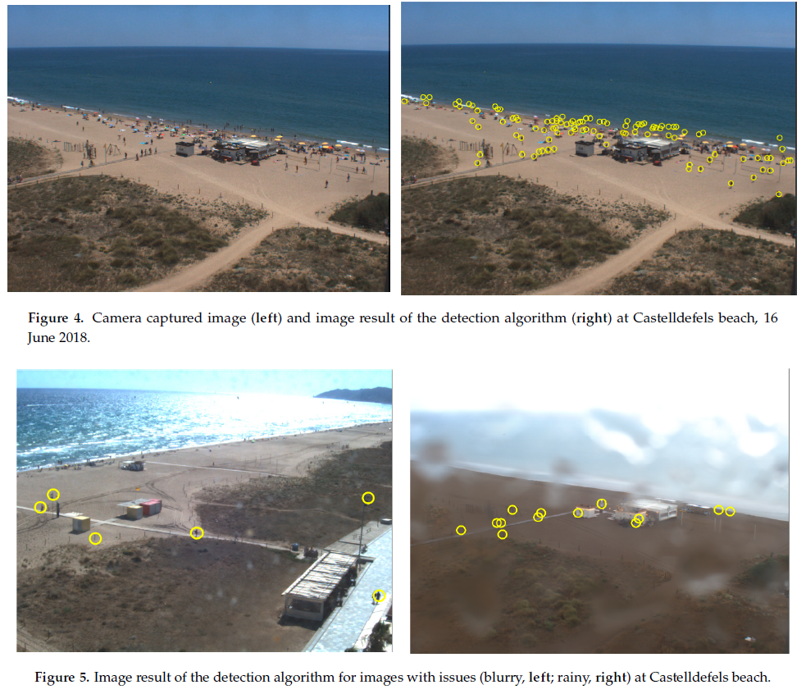

### 3.3.5 Key Parameters for Optimal Surfing Wave Conditions

Understanding the fundamental characteristics of a surfing wave is essential for evaluating good surf conditions. According to Scarfe et al. (2003), four primary parameters define optimal surfing waves: breaking wave height (Hb), wave peel angle (α), wave breaking intensity (BI), and wave section length (SL). Breaking wave height, measured from crest to trough, is crucial as it determines the size and power of the wave. The peel angle influences the wave's speed, requiring surfers to match their pace with the break. Wave breaking intensity, shaped by the seabed gradient, affects the wave’s force, with steeper waves providing more power for maneuvers. Lastly, wave section length dictates how surfers can navigate different parts of a wave, with changes in wave height, peel angle, or intensity offering varying opportunities for performance. These four parameters are vital for analyzing and predicting optimal surf conditions.[5]

Author’s : [Scarfe, B. E.](https://escholarship.org/search/?q=author%3AScarfe%2C%20B.%20E.) , [Elwany, M. H.S.](https://escholarship.org/search/?q=author%3AElwany%2C%20M.%20H.S.) , [Mead, S. T.](https://escholarship.org/search/?q=author%3AMead%2C%20S.%20T.) , [Black, K. P.](https://escholarship.org/search/?q=author%3ABlack%2C%20K.%20P.) .

## 3.4 Existing Tools for Surf Condition Analysis

Modern technology offers several tools to track waves and beach status, providing surfers and beachgoers with essential information to determine optimal conditions. These tools include beach cameras, wave forecasts, and weather forecasts.

### 3.4.1 Beach Cameras:

Live streaming cameras installed on beaches allow real-time observation of wave conditions. Websites and apps host these streams, providing surfers with visual data to assess surf conditions.

### 3.4.2 Wave Forecasts:

Specialised websites and apps offer wave forecasts, predicting wave height, period, and direction. These forecasts are often based on data from meteorological and oceanographic models.  
**Surfline**: Employs a team of forecasters to provide daily updates and detailed wave forecasts. The forecasts are based on data from various meteorological sources and are presented in a user-friendly format.  
**goSurf**: Utilises data from leading meteorological and oceanographic companies to offer detailed wave forecasts and surf conditions.

### 3.4.3 Weather Forecasts:

Weather conditions significantly impact wave quality and beach safety. Accurate weather forecasts are crucial for planning surf sessions.  
**Windy**: Offers detailed weather forecasts, including wind speed and direction, which are critical factors for wave quality.  
**Magicseaweed**: Provides weather forecasts alongside wave predictions, helping surfers to understand the overall conditions.

### 

### 

### 

## 3.5 computer vision background

### 3.5.1 Image Classification Using Machine Learning

Image classification involves sorting images into one or more predefined categories. While humans can instinctively and easily categorise images, it's a more complex task for automated systems. Machine learning, particularly through the use of algorithms, enables systems to learn and identify patterns from both organised and unorganised datasets. One prominent machine learning approach for this task is deep learning, which uses multiple hidden layers within a model to achieve accurate classification.

### 3.5.2 CNN Image Classification

Convolutional Neural Networks (CNNs) are frameworks designed using machine learning principles. They can independently learn and train on data with minimal human intervention, requiring only some pre-processing. CNNs develop and adapt their own image filters, which otherwise need to be manually coded in most other algorithms and models. These networks comprise layers that perform various functions, enabling CNNs to carry out image classification tasks effectively.

### 3.5.3 YOLO (You Only Look Once)

YOLO is a state-of-the-art object detection algorithm known for its speed and accuracy. Unlike traditional object detection methods that use a region proposal network (RPN) to identify objects, YOLO frames object detection as a single regression problem, straight from image pixels to bounding box coordinates and class probabilities. Key features include:

* **Single Convolutional Neural Network**: YOLO uses a single CNN to predict multiple bounding boxes and class probabilities simultaneously.
* **Real-Time Detection**: Capable of processing images at high frame rates, making it suitable for real-time applications.
* **Accuracy**: YOLO achieves high accuracy in detecting objects, with a low rate of false positives.
* **Applications**: Widely used in various applications such as autonomous driving, security surveillance, and sports analytics.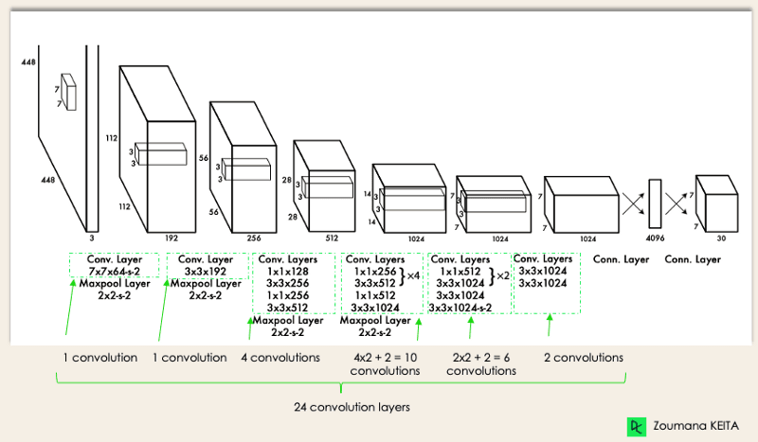

## 

# 4. Engineering Process

The engineering process for developing WaveWatch involves creating a sophisticated app designed to provide real-time sea condition analysis. The process begins with gathering and analysing user requirements to define key features. We then design a system architecture using the YOLO (You Only Look Once) algorithm for efficient and accurate object detection. Following this, we collect and preprocess video data to train our AI models for detecting and analysing sea conditions. The app is developed with a focus on a user-friendly interface that delivers clear and actionable insights. Finally, extensive testing and optimization ensure that the app operates reliably and meets user expectations, offering valuable real-time information in an accessible format.

## 4.1 Process

The process for developing WaveWatch involves defining user requirements, designing an efficient system architecture using the YOLO algorithm, and training AI models with video data. The app is then developed with a user-friendly interface for real-time analysis and undergoes thorough testing and optimization to ensure reliability and performance.

### 4.1.1 Methodology

For the development of WaveWatch, we employ the Agile methodology to ensure flexibility, continuous improvement, and iterative progress. This approach is well-suited for projects involving complex AI systems and dynamic user requirements.

#### 4.1.1.1 Initial Planning:

In the initial planning phase, the objective is to define the project scope, key features, and user requirements through collaborative discussions with stakeholders. The approach involves creating a high-level roadmap that outlines major milestones and deliverables, setting a clear path for the project's development and ensuring alignment with stakeholder expectations.

#### 4.1.1.2 Sprint Planning:

Sprint planning aims to break down the project into manageable tasks and prioritize them into iterative development cycles known as sprints. The approach involves planning and assigning tasks for each sprint, concentrating on specific features or improvements, with each sprint typically lasting 2-4 weeks.

#### 4.1.1.3 Development and Implementation:

The objective of development and implementation is to develop the app incrementally, with each sprint producing a potentially shippable product increment. The approach involves using Agile practices such as daily stand-ups, sprint reviews, and retrospectives to ensure continuous progress and adaptability to changing requirements. This includes implementing the YOLO algorithm, developing AI models, and building the app’s user interface in iterative cycles.

#### 4.1.1.4 Continuous Integration and Testing:

Continuous integration and testing is to ensure the app functions correctly and meets quality standards through regular integration and testing. The approach involves integrating and testing new features continuously within each sprint, performing unit testing, integration testing, and user acceptance testing to promptly identify and resolve any issues.

#### 4.1.1.5 User Feedback and Refinement:

User feedback and refinement is to gather feedback from users and stakeholders to refine the app and enhance its functionality. The approach involves conducting sprint reviews and collecting user feedback to make iterative improvements, adjusting features and priorities based on real-world usage and input.

#### 4.1.1.6 Deployment and Maintenance:

The objective is to release the app to users and provide ongoing support and updates. The approach involves deploying the app in phases, beginning with a beta release to a select group of users. Performance is monitored, issues are addressed, and regular updates are implemented based on user feedback and evolving requirements.

#### 4.1.1.7 conclusion

By adopting the Agile methodology, WaveWatch benefits from a flexible development process that allows for continuous improvement, quick adaptation to changes, and a focus on delivering a high-quality, user-centric product.

### 4.1.2 Expected Achievements:

Our product, WaveWatch, aims to revolutionise how surfers and beach-goers experience real-time sea conditions. By leveraging advanced AI technology, our system will deliver a fast, intuitive, and (hopefully) highly accurate analysis of wave and sea conditions, catering to both novice and experienced users.

The user-friendly interface will simplify the complex task of evaluating sea conditions, providing clear and actionable insights quickly. Whether it's for planning the perfect surf session, ensuring safety for swimmers, or optimising fishing trips, WaveWatch will offer a streamlined and efficient solution for all stakeholders.

#### 4.1.2.1 Product Infrastructure and Flow:

Data Acquisition: Integrate video feeds to collect data on sea conditions, including wave characteristics and surfer activity.  
AI Processing: Apply YOLO-based convolutional neural networks (CNNs) to analyse the collected data, detecting and classifying key parameters such as wave pockets, surfer counts, and time intervals.  
Information Delivery: Design and implement an app interface that presents analysed data through user-friendly visualisations.

#### 4.1.2.2 Criteria for Success:

Analysis Accuracy: Achieve high precision in detecting and analysing sea conditions, with accuracy metrics for wave pockets, surfer density, and wave intervals meeting established benchmarks.  
User Satisfaction: Obtain positive feedback from a diverse user base, indicating that the interface is intuitive, the data is actionable, and the system meets their needs effectively.  
System Reliability: Ensure robust system performance with minimal downtime and consistent accuracy across different weather conditions and times of day.  
Stakeholder Adoption: Secure adoption and integration of the system among key stakeholders, including surf clubs, municipalities, and insurance companies, evidenced by engagement and usage metrics.

### 

#### 4.1.2.3 Unique Features

##### 4.1.2.1.1 YOLO-Based Real-Time Analysis

Utilises the YOLO (You Only Look Once) architecture to provide rapid and accurate detection of key parameters such as wave pockets, surfer counts, and attack periods in real-time. This advanced AI approach ensures high precision and speed in processing live video feeds.

##### 4.1.2.1.2 Multi-Parameter Evaluation

Analyses multiple sea conditions simultaneously, including the amount and duration of wave pockets, wave intervals, and surfer activity. This comprehensive approach delivers a nuanced understanding of sea conditions that surpasses the capabilities of traditional methods.

##### 4.1.2.1.3 Customizable User Interface

Features an app interface. Users can tailor the display to focus on parameters that are most relevant to their specific activities, whether it’s surfing, swimming, fishing, or lifeguarding.

##### 4.1.2.1.4 Safety Insurance

Provides alerts about significant sea safety risks (surf related). Users receive a visualised and written report of the given video, risks are calculated from the video and help users make informed decisions quickly, enhancing both safety and efficiency.

##### 4.1.2.1.5 Enhanced Data Visualization

Incorporates advanced data visualisation techniques to present complex sea condition data in an easily understandable format. Interactive graphs, heatmaps, and dynamic charts facilitate quick comprehension and decision-making.

## 

## 4.2 Product

### 4.2.1 Product Architecture

#### 

#### 

#### 

#### 

#### 

#### 

#### 

#### 

The WaveWatch project employs a streamlined architecture to analyse beach videos and assess sea conditions. The process begins with the user uploading a video into the application. Using advanced computer vision techniques based on the YOLO architecture, the system detects and identifies surfers and waves within the video. Once detected, the application tracks the movement of both surfers and waves over time to gather comprehensive data. This data is then subjected to a detailed analysis to evaluate various sea conditions, including swell period,wave duration,surfers count, wave count per swell period. The resulting insights help determine whether the conditions are favourable for surfing. Through this robust workflow, WaveWatch provides users with actionable information to enhance their beach experience and ensure safety.

#### 

### 4.2.2 use case :

This use case diagram represents the "WaveWatch" system, where a user uploads a video and selects criteria for analysis. The system, using an AI model, analyses video frames with extension points like marking corners, counting surfers, and measuring wave times to assist in assessing surfing conditions.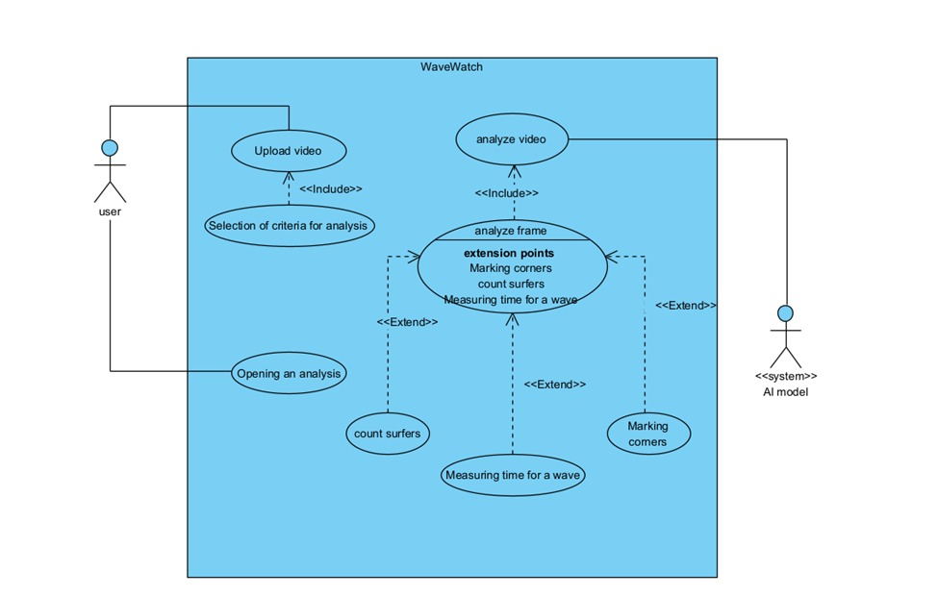

### 4.2.3 user interface:

The user interface (UI) of the WaveWatch application will be designed to be intuitive and user-friendly, allowing users to interact seamlessly with the analysis results. Key features of the UI will include:

#### 4.2.3.1 Dashboard

A central dashboard will provide an overview of the analysis, displaying key metrics such as wave length, swell period, and surfer counts in a summarised format.

#### 4.2.3.2 Video Playback

Users will be able to upload and view videos, with the capability to play, pause, and navigate through the footage. Detected parameters will be highlighted in the video, with visual overlays such as bounding boxes and labels.

#### 4.2.3.3 Detailed Reports

Users can generate and view detailed reports that include graphical representations of wave conditions, surfer activity, and other relevant metrics. These reports will include charts, graphs, and heatmaps for a comprehensive understanding of the sea conditions.

#### 4.2.3.4 Parameter Analysis

An interactive section will allow users to explore specific parameters in detail. For example, users can select a particular wave pocket to view its length, swell period, and associated surfer activity.

The combination of advanced algorithms, structured data management, and a user-friendly interface aims to provide a powerful tool for analysing and optimising beach activities based on real-time video data.

### 4.2.4 paper prototype

### 

### 

### 

### 

### 

### 

### 

### 

The first screen, known as the Dashboard, serves as the entry point for users. Here, users have the option to upload a video of the waves they want to analyze. They can also select specific sea parameters that they are interested in examining, such as swell period or wave duration. Once these parameters are chosen, users can initiate the analysis by pressing the "Start" button. This action transitions the user to the next screen.

### 

### 

### 

### 

### 

### 

### 

### 

The second screen is the Loading Screen. This screen is displayed while the application processes the video. During this phase, a visual indicator, such as a progress bar or animation, shows that the system is working on calculating the relevant data. This screen helps users understand their current position in the process and provides an estimate of the remaining time for the analysis to complete. By offering a clear indication of progress and estimated time, the Loading Screen ensures users are informed and can manage their expectations while waiting for the results. This stage is crucial for the application to generate accurate analysis results based on the uploaded video.

Finally, the third screen, called the Analysis Screen, presents the results of the video analysis. The analyzed video is displayed with annotations that highlight important findings, such as wave height and other critical metrics. Alongside the video, the parameters selected by the user are shown for reference. Additionally, users have the option to screenshot the analysis, making it easy to save and review. After reviewing the results, users can return to the Dashboard to upload new videos or adjust the parameters for further analysis.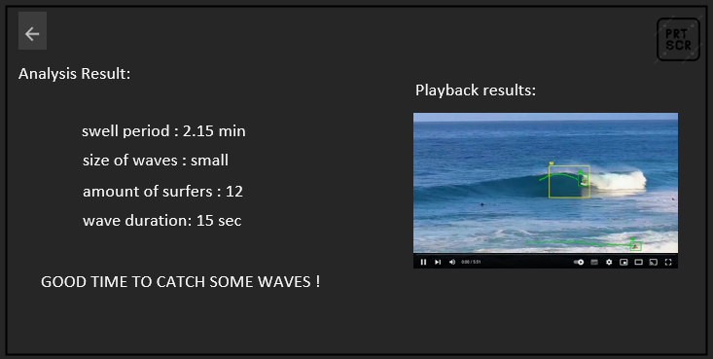

### 4.2.5 Activity Diagram

This activity diagram outlines the user and system interactions for the WaveWatch application. The process begins when the user launches WaveWatch by running the application. The next step for the user is to upload a video, which is then checked by the system to ensure that the video format is valid. If the video format is invalid, the system prompts the user to upload a valid video.

Once the video format is confirmed as valid, the user is presented with the option to select various parameters for analysis. The system waits until the user completes their parameter selection. If the user hasn't finished, they can continue choosing parameters. After the user completes the selection, they click the "Start" button, triggering the analysis based on the chosen parameters.

The system then moves into the analysis phase, displaying a loading screen while the video is processed. Once the analysis is complete, the system displays the results on a popup screen. If the analysis is still ongoing, the system refreshes the loading screen until the process finishes.

After the analysis results are displayed, the user is given two options: either conduct another analysis or take a screenshot of the current results. If the user chooses to take a screenshot, the system captures and saves the analysis results. The user can then return to the start by clicking the back button, repeating the process or ending the session.

This flow ensures a user-friendly interaction with clear decision points, providing a seamless experience while analyzing videos for sea conditions.

### 

### 4.2.6 Package Diagram

The diagram primarily highlights the Sea Condition Analysis Package, which is responsible for processing key sea condition parameters such as the swell period, wave duration, wave count for a given swell period, and the surfer count. This package relies on input from the Video Processing Pipeline, which utilises a YOLO model for object detection. The model generates bounding boxes and labels for each detected object in video frames, such as surfers or waves. A Frame Extraction Service within the pipeline prepares video frames for analysis by isolating them from the uploaded video footage. The interaction between the sea condition analysis and video processing components is key to the system's functionality, enabling accurate detection and measurement of various sea and crowd parameters from the video data. The backend coordinates these processes, while the user interface serves as an entry point for video uploads and output visualisation, though it plays a lesser role in the core functionality compared to the analysis and processing packages.

### 

### 4.2.7 Requirements

The feedback from the surfing community survey significantly influenced the functional and non-functional requirements of the WaveWatch project. Functionally, the surfers emphasized the need for real-time data on wave conditions, such as swell period, wave duration, and surfer count, leading to the integration of these parameters into the model. Their input ensured the system would deliver accurate and timely information, helping surfers plan their sessions more effectively. Non-functionally, the survey underscored the importance of a simple and responsive interface that even beginner surfers could navigate easily, while also ensuring reliability for more experienced users who depend on precise data for advanced surfing activities.

#### 4.2.7.1 Functional Requirements

1. Video Upload and Management:
   * Users must be able to upload beach videos in standard formats (e.g., MP4).
   * The system should support batch uploading and provide progress indicators.
2. Video Processing:
   * The system must extract frames from videos at configurable intervals.
   * The YOLO model should detect and classify objects within the frames, including waves and surfers.
3. Parameter Detection:
   * The system should accurately identify and measure key parameters such as wave length, swell period, attack period, number of surfers, and wave duration.
   * Detected parameters must be displayed with confidence scores and visual markers on the video.
4. User Interface:
   * Users must have access to a dashboard displaying summarised metrics of video analysis.
   * A video playback feature should allow users to view the processed video with overlaid detection results.
   * The system should offer detailed reports with graphical representations of detected parameters.
5. Customizable Views:
   * The system should allow users to filter and analyse specific parameters of interest.
6. Error Handling and Notifications:
   * The system must handle errors gracefully and provide clear error messages to the user.
   * Notifications should inform users about the status of video processing and any issues encountered.

#### 4.2.7.2 Non-Functional Requirements

1. Performance:
   * The system must process videos and provide results within a reasonable timeframe, depending on video length and complexity.
   * The YOLO model should deliver detection results with high accuracy and minimal latency.
2. Scalability:
   * It must be designed to scale with increasing numbers of users and video data.
3. Usability:
   * The user interface must be intuitive and easy to navigate, with clear instructions and tooltips.
   * The system should provide a responsive design that works well on various screen sizes and resolutions.
4. Reliability:
   * The system must be robust and handle unexpected failures or interruptions without data loss.
5. Compatibility:
   * The application should be compatible with major operating systems (e.g., Windows, macOS) and standard video formats.
   * It must function correctly with varying hardware configurations, including different types of video cameras.
6. Maintainability:
   * The system codebase should be well-documented and modular, facilitating easy updates and maintenance.
   * The system should support version control to manage changes and track modifications over time.
7. Documentation:
   * Comprehensive user documentation should be provided, including guides for video upload, analysis, and report generation.
   * Technical documentation should detail the system architecture, algorithms used, and data structures for developers.

These requirements will ensure that the WaveWatch system is effective in analysing beach videos while being reliable, secure, and user-friendly.

## 

## 4.3 Testing Plan

Test 1: run WaveWatch application.

| # | Action | Expected Result |
| --- | --- | --- |
| 1 | Run app.py on application directory | WaveWatch application should be started with Start screen |

Test 2: upload a video to WaveWatch application.

| # | Action | Expected Result |
| --- | --- | --- |
| 1 | Run app.py on application directory | WaveWatch application should be started with Start screen |
| 2 | Drag a .mp4 file to dedicated space on the app | Video uploaded successfully pop up |

Test 3: choose parameters to analyse on WaveWatch application.

| # | Action | Expected Result |
| --- | --- | --- |
| 1 | Run app.py on application directory | WaveWatch application should be started with Start screen |
| 2 | Drag a .mp4 file to dedicated space on the app | Video uploaded successfully pop up |
| 3 | Mark the checkbox or boxes of parameters you want to analyse the video based on | Start button should be coloured at that point |

Test 4: analyse a video on WaveWatch application.

| # | Action | Expected Result |
| --- | --- | --- |
| 1 | Run app.py on application directory | WaveWatch application should be started with Start screen |
| 2 | Drag a .mp4 file to dedicated space on the app | Video uploaded successfully pop up |
| 3 | Mark the checkbox or boxes of parameters you want to analyse the video based on | Start button should be coloured at that point |
| 4 | Click on ‘start’ button | Loading screen popup |

Test 5: analyse a 2nd video on WaveWatch application.

| # | Action | Expected Result |
| --- | --- | --- |
| 1 | Run app.py on application directory | WaveWatch application should be started with Start screen |
| 2 | Drag a .mp4 file to dedicated space on the app | Video uploaded successfully pop up |
| 3 | Mark the checkbox or boxes of parameters you want to analyse the video based on | Start button should be coloured at that point |
| 4 | Click on ‘start’ button | Loading screen popup + analysis and playback screen popup |
| 5 | Click on ‘back’ button | Popsup first screen of video upload and parameters selection |
| 6 | Repeat steps 1-5 | Loading screen popup + analysis and playback screen popup |

Test 6: screenshot an analysis on WaveWatch application.

| # | Action | Expected Result |
| --- | --- | --- |
| 1 | Run app.py on application directory | WaveWatch application should be started with Start screen |
| 2 | Drag a .mp4 file to dedicated space on the app | Video uploaded successfully pop up |
| 3 | Mark the checkbox or boxes of parameters you want to analyse the video based on | Start button should be coloured at that point |
| 4 | Click on ‘start’ button | Loading screen popup + analysis and playback screen popup |
| 5 | Click on ‘prtscn’ button | A screenshot of the analysis page will be taken to a local directory running the app. |

## 

# 5. References:

1. Classification of Surf Breaks in Relation to Surfing Skillt James A. Huttf, Kerry P. Blackt and Shaw T. Meadt.
2. Artificial intelligence for beach monitoring: An experimental study of beach attendance at El Rodadero, ColombiaRichard Johnston-Gonzáleza, b, Eros Adarragaa, Oswaldo Cocaa, Marco Correaa.
3. Analysis of Waves and Human Interaction Using Beach Webcams Harel Mendelman Tomer Masssas Yair Moshe Signal and Image Processing Laboratory (SIPL), Andrew and Erna Viterbi Faculty of Electrical & Computer Engineering Technion – Israel Institute of Technology, Haifa, Israel.
4. Deep Learning and Internet of Things for Beach Monitoring:  
   An Experimental Study of Beach Attendance Prediction at Castelldefels BeachMari Carmen Domingo
5. The Science of Surfing Waves and Surfing Breaks - A Review
6. How to Read Surf Forecast & What Makes It a Great Day to Surf?:  
   [How to Read Surf Forecast & What Makes It a Great Day to Surf? - Lapoint Surf camps (lapointcamps.com)](https://www.lapointcamps.com/blog/how-to-read-surf-forecast/)
7. <https://beachcam.co.il/batgalim.html>
8. <https://www.surfline.com>
9. <https://github.com/ultralytics/yolov5>
10. <https://docs.python.org/3/>
11. <https://colab.research.google.com>
12. <https://chatgpt.com>

# 6. Appendices

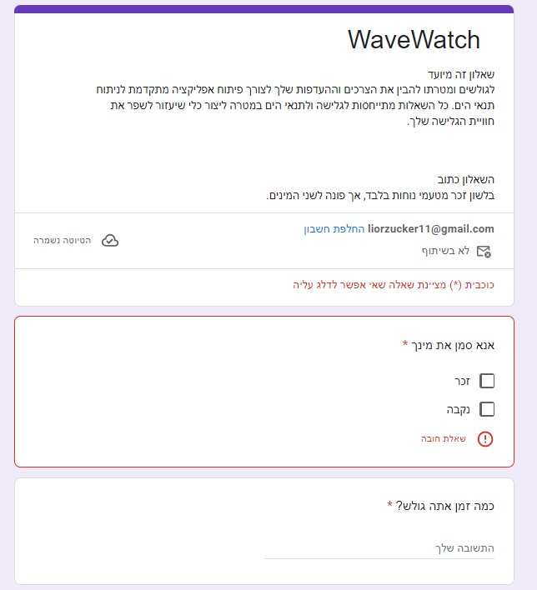

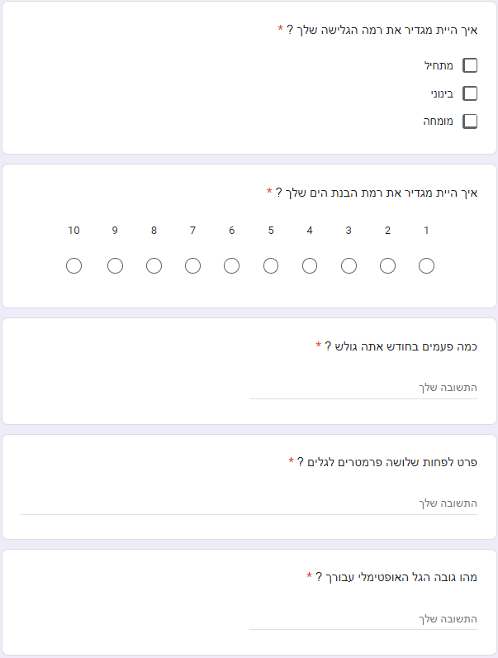

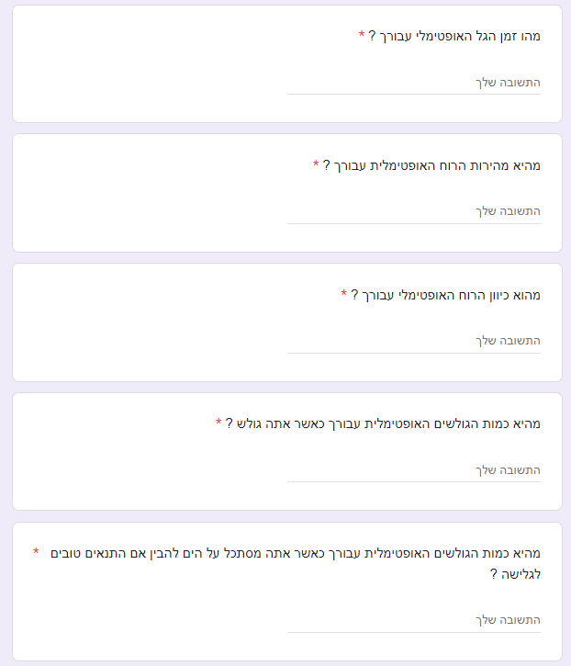

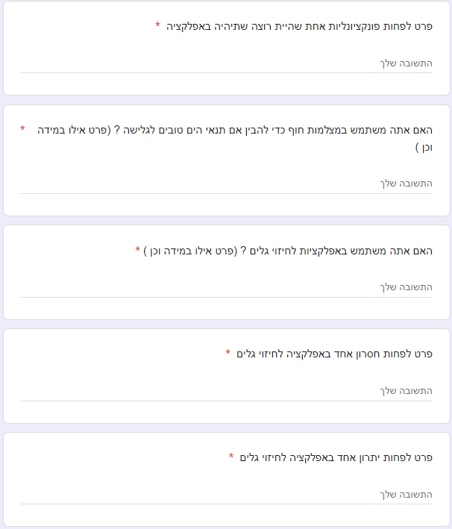

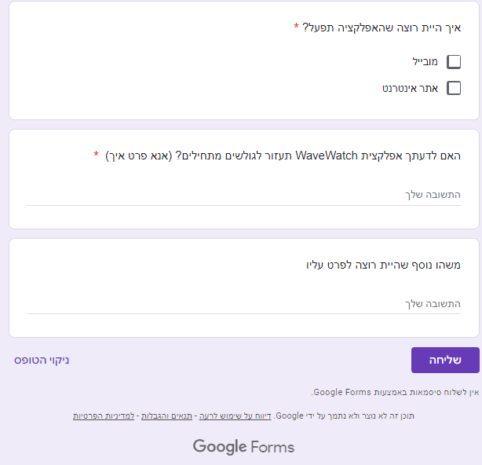

2.

